**DIGITAL NURTURE 4.0 DEEP SKILLING JAVA FSE-WEEK1**

**NAME: SIVITHA GUNASEKARAN**

**SUPERSET ID: 6413354**

**WEEK 1: ALGORITHMS DATA STRUCTURES**

**Exercise 6: Library Management System**

**Scenario:**

You are developing a library management system where users can search for books by title or author.

**Steps:**

1. **Understand Search Algorithms:**
   * Explain linear search and binary search algorithms.
2. **Setup:**
   * Create a class **Book** with attributes like **bookId**, **title**, and **author**.
3. **Implementation:**
   * Implement linear search to find books by title.
   * Implement binary search to find books by title (assuming the list is sorted).
4. **Analysis:**
   * Compare the time complexity of linear and binary search.
   * Discuss when to use each algorithm based on the data set size and order.

**CODE SAMPLES:**

import java.util.*;

class Book {

int bookId;

String title;

String author;

public Book(int id, String title, String author) {

this.bookId = id;

this.title = title;

this.author = author;

}

public String toString() {

return bookId + " | " + title + " | " + author;

}

}

public class LibrarySearchSystem {

public static int linearSearch(Book[] books, String title) {

for (int i = 0; i < books.length; i++) {

if (books[i].title.equalsIgnoreCase(title)) return i;

}

return -1;

}

public static int binarySearch(Book[] books, String title) {

int low = 0, high = books.length - 1;

while (low <= high) {

int mid = (low + high) / 2;

int cmp = books[mid].title.compareToIgnoreCase(title);

if (cmp == 0) return mid;

else if (cmp < 0) low = mid + 1;

else high = mid - 1;

}

return -1;

}

public static void main(String[] args) {

Book[] books = {

new Book(1, "Java Basics", "Herbert"),

new Book(2, "C Programming", "Dennis"),

new Book(3, "Python", "Guido")

};

int index1 = linearSearch(books, "Python");

System.out.println("Linear Search: " + (index1 != -1 ? books[index1] : "Not found"));

Arrays.sort(books, Comparator.comparing(b -> b.title));

int index2 = binarySearch(books, "Java Basics");

System.out.println("Binary Search: " + (index2 != -1 ? books[index2] : "Not found"));

}

}

**MY SCREENSHOT PROOFS:**

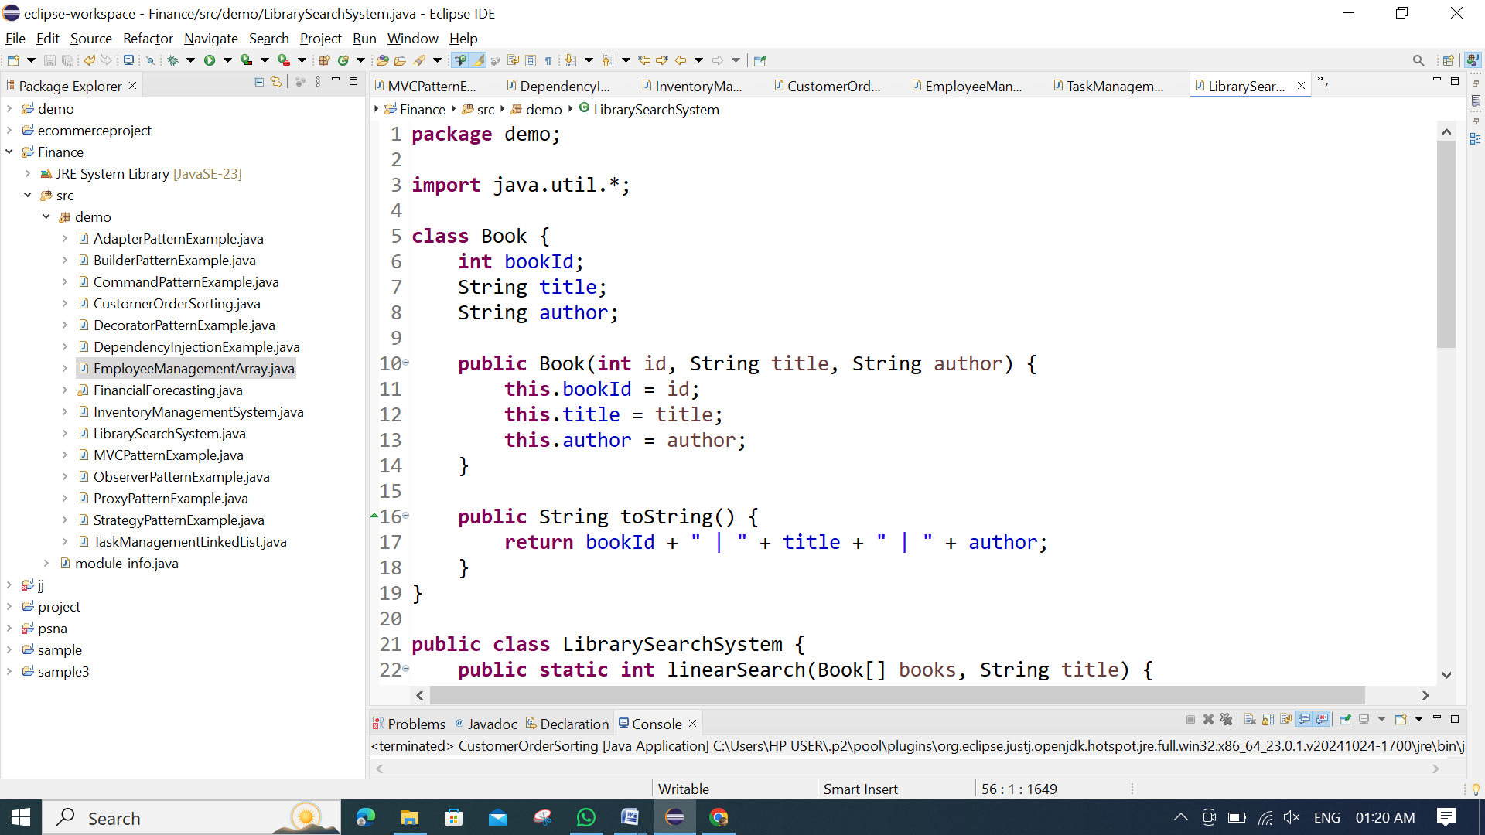 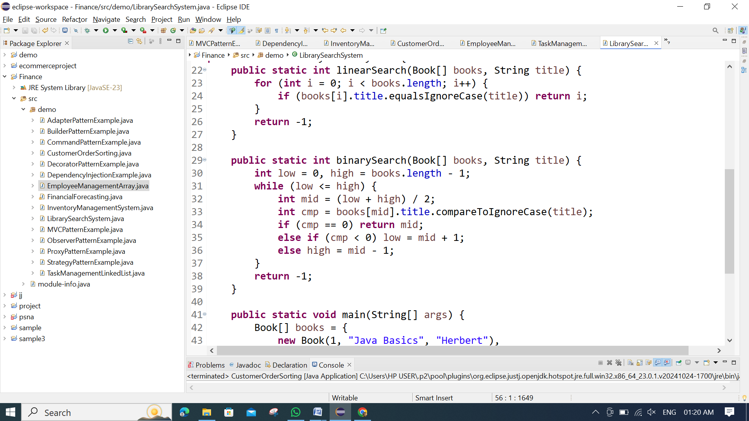 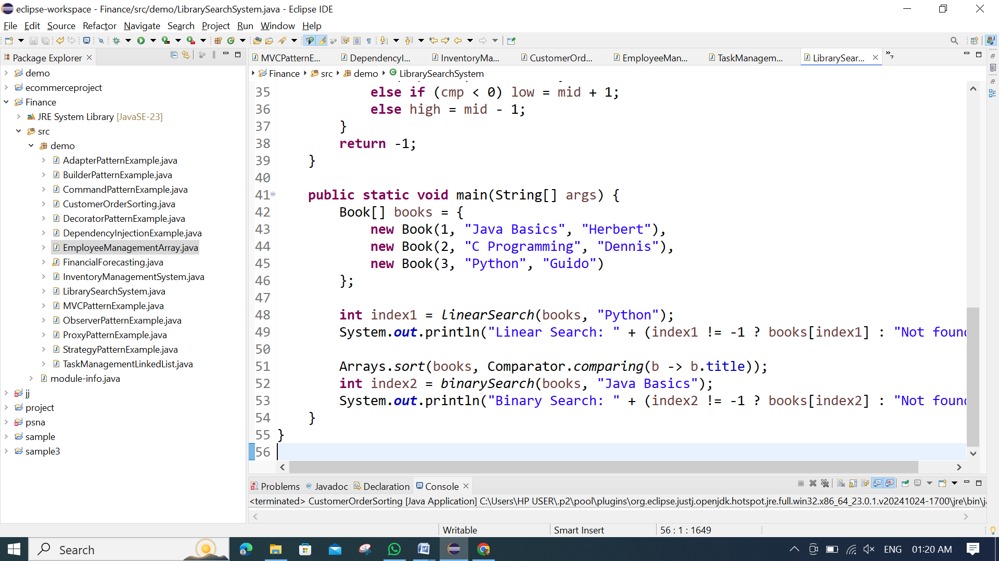

**OUTPUT:**

